World History One-Pager
A one-pager is a tool that you can use for EACH UNIT to help you review and remember elements from the unit for assessments as well as the final exam. The more detailed the one-pager the more helpful it will be as a tool for review.

Requirements:
- One-pagers MUST be completed in totality BY HAND. Name and class period should be written on the back.
- No duplications between elements (ex: if you use a person as a significant person then they should not appear in your questions.)
- One-pagers MUST be completed in COLOR.
- One-pagers MUST take up the ENTIRE page.

Elements:
- Title and time period (dates).
- Overview of the time that answers the following questions:
  - What was this time known for?
  - How would you characterize life during this time?
- TWO pictures of something significant during this unit (ex: when we are studying Ancient Egypt, you may choose to draw a pyramid.)
- TWO significant people from the unit AND what they are known for (must be at least three sentences).
- TWO vocabulary words AND definitions.
- TWO questions AND correct answers. DO NOT USE information from other elements.
- TWO significant events AND why they are significant.
- TWO cultural achievements AND what the achievement was and why it is considered an achievement.
- Map of the territory included in the unit.

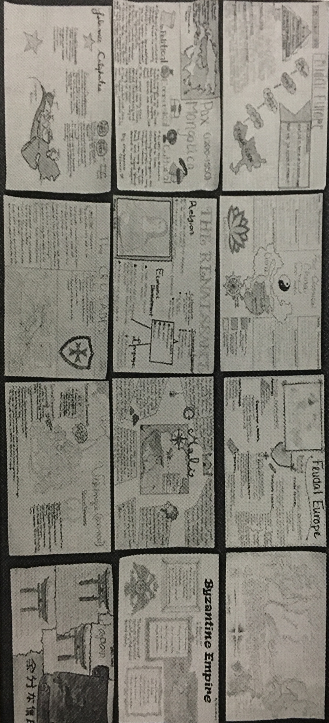

Rubric
Requirement | 1 Point | 2 Points | 3 Points | 4 Points | 5 Points | TOTAL
Format | Completed by hand, but is not in color, OR does not take up the entire page. | Completed by hand, some parts are in color, and takes up the some of the page. | Completed by hand, some parts are in color, and takes up most of the page. | Completed by hand, some parts are in color, and takes up the entire page. | Completed by hand, in color, and takes up the entire page.
Title/Overview | Both title and overview are missing. | Title is included but overview is missing. | Title is included and overview is somewhat detailed. | Title is included and overview is detailed but is missing one of the requirements. | Title is included and overview is detailed and includes 1) what the unit is about, and 2) how life was like during the period.
Pictures | No pictures included. | Includes ONE picture in color. | Includes TWO pictures, neither are colored, or ONE picture colored. | Includes TWO pictures, somewhat colored. | Includes TWO pictures fully colored.
People | Does not include any people. | Includes descriptions of ONE person. | Includes descriptions of ONE person AND their significance. | Includes basic descriptions of TWO people. | Includes detailed description of TWO people AND their significance.
Vocabulary | Does not include any vocabulary terms. | Includes ONE vocabulary term. | Includes ONE vocabulary term AND definition. | Includes TWO vocabulary terms. | Includes TWO vocabulary terms AND their definitions.
Questions | Does not include any questions or answers. | Includes ONE question, however, the answer is incorrect. | Includes ONE question and the correct answer. | Includes TWO questions, however, one or more answers is incorrect. | Includes TWO questions and the correct answers.
Events | Does not include any events. | Includes ONE event and somewhat accurately describes why it is significant. | Includes ONE event and describes in detail why they are significant. | Includes TWO events and somewhat accurately describes why they are significant. | Includes TWO events and describes in detail why they are significant.
Achievements | Does not include any achievements. | Includes ONE achievement and somewhat accurately describes why it was significant. | Includes ONE achievement and describes in detail why it was significant. | Includes TWO achievements and somewhat accurately describes their significance. | Incudes TWO achievements and describes in detail why it was significant
Map | Does not include a map. | Includes a map. | Includes a map with some labels. | Includes a somewhat detailed COLOR map with some labels. | Includes a detailed COLOR map lableled with major cities, trade routes, etc.
TOTAL

