Changes in World Population
By 2011, world population had soared to 7 billion. Here, London commuters make their way through the Liverpool Street railway station. In 2010, the population of the metropolitan area of London was nearly 8 million people.
In 1960, the world's population reached 3 billion. By 2011, it had soared to about 7 billion. How high will it go? Some demographers, or experts in the study of human populations, believe that the number of people on planet Earth will level off sometime in the 21st century. The population will continue to rise in some countries as it falls in others. In either case, changes in world population will likely have profound effects.
Population Change
The world population will continue to rise as long as more people are born each year than die. It will fall when, and if, the reverse becomes true. The rise or fall of the population in any one country, city, or other defined area has a somewhat different basis. Four factors determine how a population changes in a given area. They are births, deaths, immigration (migration into), and emigration (migration out of). Births and immigration add to the population. Deaths and emigration subtract from it.
Countries with a high birthrate can gain population quickly, especially if the death rate is low. Birthrate is the number of births divided by the population during a given period. It is often expressed as births per 1,000 people in a year. Death rate is the number of deaths per 1,000 people in a year.
Related to the death rate is another concept, life expectancy. Life expectancy is the average number of years people live within a given population. Like the birth and death rates, this figure varies from country to country. In Afghanistan in 2010 a newborn baby had a life expectancy of around 47 years. A baby born in France had a life expectancy of around 80 years. Factors that affect life expectancy include disease, nutrition, sanitation, and access to medical care.
Related to the birthrate is the total fertility rate (TFR). The TFR is the average number of children women would give birth to in their lifetimes if the current birthrate did not change. In many of the countries of Europe, East Asia, and North America the fertility rate has remained fairly low for decades. Generally, women in those countries give birth, on average, to two or fewer children in their lifetimes. In some of those countries, such as the United States, immigration keeps the population higher than it would otherwise be.
Population Distribution
Demographers also study population distribution, or how a population breaks down into categories. One category a demographer may analyze is population distribution by geography. More people may live in one area of a country than in another. Demographers determine differences by measuring how densely various areas are populated. The number of people in a given land area is that area's population density.
The population of urban areas is much denser than that of rural areas. Today, urbanization—the process of forming and expanding towns and cities—is increasing. In 2008, for the first time, most of the world's people lived in cities. The percentage of people living in urban areas could grow to 70 percent by 2050.
Rural-to-urban migration has been a fact of life since the Industrial Revolution. Industries tend to locate in urban areas, where they have ready access to supplies, transportation, and labor. People migrate to cities, in large part, because that is where the jobs are. This is true in India, where some of the most densely populated cities in the world are located. One Indian city, Mumbai, has about 11,500 people per square mile. The American city of Chicago, in contrast, has a density of about 585 people per square mile.
Population distribution can also be examined in terms of gender. At its simplest, this involves counting how much of a country's population is male and how much is female. But demographers study gender statistics for many other reasons. They can use gender statistics to measure the status of men and women in a society. They look for unfairness in jobs, education, health care, politics, and other spheres of life. Where they find a lack of equality, demographers can urge the government to search for ways to close the gender gap.
India has some of the most densely populated cities in the world. In some Indian cities, many people live in crowded slums, such as this Mumbai neighborhood.
Another way that population is distributed is by age. Age data can reveal the size of a country's youth population, its working-age population, and its elderly population. Too many young people can place a burden on parents and schools. Too few young people might lead to a future shortage of workers, which could limit economic growth. Too many elderly might place a strain on health-care and other social support systems.
Population Challenges
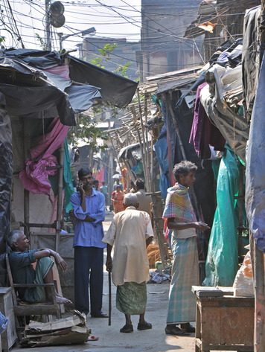
In the late 1960s, the world experienced a population explosion. Between 1960 and 1999, the population doubled, from 3 billion to 6 billion. Demographers thought that dealing with this enormous growth would be the main population challenge facing humans in the future. In the 1990s, however, the growth rate began to slow. The population was still expanding, but at a less extreme pace.
In 2010, the world's birthrate was 20 and the death rate was 8. That gap explains why the population of the world continues to increase. What it fails to show, however, is that the birthrate has been declining for several decades, as has the fertility rate. The death rate has also been falling, but not as rapidly. If these trends continue, annual births and deaths will one day be equal. The world's population will stabilize. Nevertheless, today, individual countries still face serious population challenges.
One basic challenge some nations face is simply having too many people. Birth and fertility rates remain high in many developing countries. The nations of the developing world have less industrialized economies than those of highly developed regions such as Europe. Their people, in general, have lower incomes and lower standards of living.
Developing countries often lack the resources to support their growing populations. China faced this problem as early as the 1950s. It could not grow enough food to feed its people. In 1979, China instituted a one-child policy to try to limit the population. This drastic program of birth control required Chinese couples to limit their families to a single child. The one-child policy has slowed China's growth rate, but it has created another problem. The one child in a family may be the sole caregiver of his or her aging parents and grandparents.
The problem of taking care of an aging population may, in fact, be the main demographic challenge of the 21st century. Over the past 50 years, women have been giving birth to fewer children on average, and improvements in agriculture and public health have allowed people to live longer. These trends have created an increasingly elderly population in many developed countries, such as Japan and Germany. Meanwhile, many developing countries, such as Rwanda, are still dealing with the challenges of a growing population.
Efforts to limit population growth in Rwanda have been largely unsuccessful. In 2011, the population was increasing at one of the fastest rates in the world. As a result, Rwanda is a very youthful country.
Rwanda
The recent history of Rwanda has made it difficult to limit population growth. In 1990, tensions between this Central African nation's two main ethnic groups, the Hutus and the Tutsis, sparked a civil war. In 1994, the governing Hutus perpetrated a genocide—the systematic killing of people from a particular ethnic, racial, or religious group—wiping out three quarters of the Tutsi population.
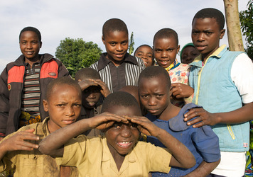
Because so many Rwandans had died in the war, many parents felt a need to have many children. But despite the death toll of the recent conflict, Rwanda still had too many people. Its limited natural resources could not support them all. For this reason, Rwanda's government made family planning a priority in an attempt to control the number of children in a family. It recognized that limiting population growth was a key to ending poverty and to developing the economy. It instituted programs aimed at helping parents freely and responsibly determine the number of children that they could support and limit their family size.
Rwanda's population density in 2011 was the highest of any country on the sub-Saharan African continent. The rate at which Rwanda's population was increasing was among the highest in the world.
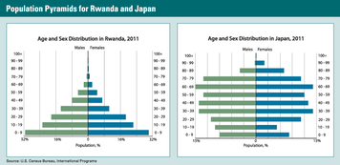
An age-sex graph, also known as a population pyramid, displays a population’s age and sex composition. These pyramids show the populations of Rwanda and Japan in 2011. The graph for Rwanda, with its wide base and narrow top, is typical of a young population. In contrast, the shape of Japan’s graph reflects an aging population. The birthrate in Japan is low, and a larger percentage of people survive into old age.

Japan and Germany
Two developed countries, Japan and Germany, face a different kind of demographic challenge. The people of Japan and Germany are not producing enough children to support an expanding elderly population. Children, in time, become workers. By paying taxes, workers contribute to the social programs upon which many retired people depend. Children also become parents and have children of their own. Countries with very low birthrates face the challenge of an aging—and even a falling—population. Demographers have projected that Japan's population will drop from 127 million in 2010 to 95 million in 2050. Germany faces the same situation.
The Germans and the Japanese have considered ways of dealing with their aging populations. They include encouraging people to have more children, raising the retirement age to keep people working, and adding more women to the work force. But the most controversial answer is immigration. Plenty of young workers from developing countries are willing to move to Germany or Japan. However, many Germans and Japanese have opposed immigration. One reason is national identity. Immigrants, they fear, might alter what it means to be “German” or “Japanese.” A further barrier in Japan is the language, which is difficult for foreign workers to learn.

Managing Natural Resources

The conditions of life vary greatly from one country to another. Some people are able to enjoy prosperity. Others are forced to merely seek survival from one day to the next. The difference between these groups is often their access to resources. One of the key challenges of the 21st century is how to manage Earth's natural resources in a way that helps all humans thrive—while limiting their negative impact on the environment.
The Three Forms of Natural Resources
Natural resources are naturally occurring materials that people find useful. They include water, soil, trees, minerals, and fossil fuels. They come in three basic forms.
Some natural resources are renewable. Unless human activities destroy them, they will replenish themselves in time. For example, a new forest will grow up after its trees have been harvested for timber.
Some natural resources are nonrenewable. Fossil fuels, such as coal, oil, and natural gas, took millions of years to form. But once humans use them, they are effectively gone forever.
Flow resources, the third form, have similar properties to renewable resources, except that they can be used only when and where they occur. They include sunlight, wind, and flowing water. Each serves as a source of energy—often called alternative, clean, or green energy.
Location of Earth's Natural Resources
Nearly every substance on Earth, and within Earth's crust, is a potential natural resource. At any one time, however, humans value certain resources more than others. Wood was once the resource of choice for use as fuel. The arrival of steam power during the Industrial Revolution cut back on the value of wood and increased the value of coal. In the 20th century, industrial countries came to rely more on petroleum, or oil. Some other form of energy may one day replace oil.
The location of resources affects where people settle and helps determine their activities. Deposits of coal or oil or gold attract people and industries whose aim is to extract those resources. Towns and cities grow up along rivers or other sources of fresh water. Farmers migrate to areas with fertile soil.
Today, fossil fuels and certain minerals are among the most highly valued natural resources. The largest reserves of oil and natural gas are found in the Middle East. The largest quantities of gold come from China, the United States, Australia, South Africa, and Russia. The most productive diamond mines are located in Australia, the Democratic Republic of the Congo, Russia, and South Africa. A relative newcomer to the list of high-value minerals is tantalum, a key metal used in computers and mobile phones. It is mined in Australia, Brazil, and Canada.
Humans have always needed water. Today, supplies of fresh water are distributed fairly evenly across the globe. However, in the desert regions of Africa, the Middle East, Australia, China, and the United States, water is scarce. In other places, drinking water is polluted or limited by drought.
Land is also an indispensable resource. People live on it. They grow crops and graze animals on it. Some of the most productive farmland is in the United States, China, Brazil, India, Mexico, and Russia. Forested land covers vast areas in Russia, Brazil, Canada, the United States, and China.
How Resources Are Developed, Distributed, and Consumed
Some of the wealthiest countries in the world are those with a large quantity of highly valued, but scarce, natural resources. China, for example, controls more than 90 percent of the world's supply of rare-earth minerals. These elements have been called “21st-century gold” because of the key role that they play in wind turbines, fuel cells, compact fluorescent light bulbs, and high-tech weaponry. Another country, Saudi Arabia, has more than a fifth of the world's known oil reserves.
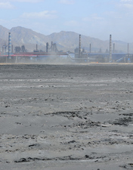
To take advantage of its resources, a country must have the technology and organization to develop and distribute them. Saudi Arabia, for example, has developed advanced technology for oil exploration, drilling, extraction, and transport. It has also designed a reliable system for marketing its product to refiners, who turn crude oil into gasoline and other products.
The major oil refiners, like many of the world's largest businesses, are multinational corporations. They have facilities—offices, factories, stores, warehouses—in multiple nations. Nearly all of these huge companies are based in the United States, Japan, or Western Europe. They include automakers, banks, retailers, and fast-food chains. Multinational corporations play a leading role in the global network of resource production, distribution, and consumption.
Unlike oil, land is a natural resource that occurs throughout the world. Land, if fertile, can be developed to produce food. Many countries have fertile land, but not all fertile land is equally productive. Through the mid-1900s, many poor countries in Asia and elsewhere experienced periodic famines. Their traditional farming methods could not produce enough food to feed growing populations. They needed help further developing their land.
Starting in the 1960s, with the aid of Western nations, Asia underwent a “Green Revolution.” Farmers turned from manual to mechanized agriculture. They applied chemical fertilizers and pesticides. They planted high-yielding varieties of rice, wheat, and other crops. As a result, between 1970 and 1995, their production of cereals more than doubled. Incomes also soared, pulling many people in Asia out of poverty.
Worldwide, the poverty rate among developing countries has been decreasing. As people in these countries gradually escape poverty, they consume more resources. They increase demand for non-local and imported goods, such as refrigerators, televisions, and cars. Today, developed countries consume most of Earth's resources by far. But rising demand from developing countries may lead to more intense competition—and conflict.
Competition for Resources
Competition for vital resources such as oil and water has already led to international disputes. In 1960, five major oil producers—Saudi Arabia, Iran, Iraq, Kuwait, and Venezuela—founded the Organization of the Petroleum Exporting Countries, or OPEC. Their goal was to coordinate their oil policies in order to keep prices high. In 1973, Arab countries placed an embargo, or ban, on the United States to punish it for supporting Israel when Egypt and Syria invaded. The embargo led to much higher prices in the United States and severe shortages of gasoline and heating oil.
In 1980, Iraq invaded Iran in part to try to take possession of its rich oil fields. Eight years of bitter fighting ended in a ceasefire. Just two years later, in 1990, Iraq invaded another of its OPEC partners, Kuwait, and captured its oil fields. In what was called the Persian Gulf War, a coalition of countries led by the United States quickly forced Iraq out of Kuwait. The demand for oil, not only from developed, industrial countries but also from the developing world will likely continue to rise. This will only intensify the competition for this scarce, nonrenewable natural resource.
In desert regions, the basic need for water can also lead to conflict. Civilizations would likely not have arisen and prospered in arid lands, such as Mesopotamia and Egypt, without their being located near rivers. Water was, and still is, the key to producing enough food for a population. Today, especially in times of drought, countries in the former lands of Mesopotamia regularly squabble over rights to the waters of the Tigris and Euphrates rivers. But in Egypt, a potential clash over the Nile River involves not just its African neighbors but also distant—and much wealthier—states.
Before its waters reach Egypt, the Nile flows north through the fertile plains of Ethiopia and Sudan. Saudi Arabia, South Korea, China, and India have all obtained large tracts of land there for farming. They use the land to grow grain, which they ship home to feed their own people. Growing this grain takes a lot of water out of the Nile.This could eventually severely reduce the flow of the Nile through Egypt, which relies on the river to irrigate its own grain crops. Water shortages could one day lead to a food crisis in Egypt—and set off conflict in northeastern Africa.
Human Impact on the Environment
In 1970, Americans celebrated the first Earth Day, a day for raising awareness of environmental issues. At the time, air and water pollution were widespread in the United States. Automobiles and factories spewed poisonous gases into the air. Cities fouled nearby waters with sewage and chemicals. Pesticides and fertilizers seeped into rivers and streams. Humans were ruining their environment and damaging their own health.
Similar problems in other countries prompted people around the world to become much more aware of the need to protect the environment. Earth Day has become an international event. As a result of this increased awareness, air and water are cleaner now, but much remains to be done.
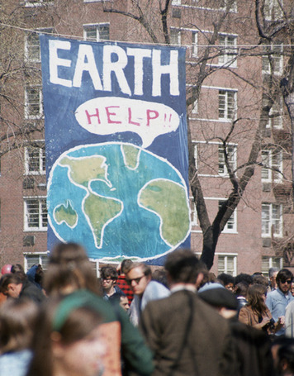
One ongoing environmental concern is global climate change. Many scientists consider it the key environmental challenge of the 21st century. They note that Earth's average temperature is rising.
These scientists warn that global warming could alter climates enough to lead to a number of problems. They think that melting glaciers and polar ice sheets will cause sea levels to rise, flooding low-lying coastal plains and submerging some islands. Extreme weather events, such as floods, droughts, and hurricanes, will become more common. The yield of certain crops, such as rice and cereals, will drop, especially in tropical regions.
Most climate scientists believe that human activities, especially the burning of fossil fuels, play a significant role in climate change.
These activities, they say, have introduced large amounts of carbon dioxide and other gases into the atmosphere since the start of the Industrial Revolution. There the gases act like a greenhouse, holding in the sun's heat and raising the temperature on Earth. This greenhouse effect, they argue, is a major cause of climate change. They warn that humans must cut back on the gases that produce the greenhouse effect or face dire consequences.
Some scientists, however, dispute that the earth is warming. Others believe that the warming of Earth is caused by natural climate cycles and not by human activities. Still, the present consensus of most of the scientific community is that global warming is a real, human-made phenomenon.

Patterns of Global Economic Interaction
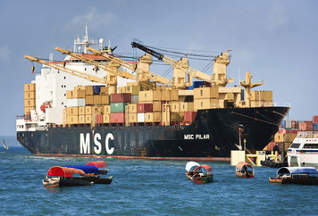
Global interaction is not a new phenomenon. By 1600, European states were carrying on a brisk trade with lands all over the world. However, the patterns of interaction have changed. More than ever before, modern countries depend on one another. They do not just trade—they form trading partnerships. They rely on the same communications and transportation systems. They are served by the same multinational corporations. Their economies are, in effect, intertwined.
Economic Interdependence
The process of increasing the interdependence of the world's economies is called globalization. In a fully globalized world, goods and services, money, and information would flow freely across national boundaries. The world's borders will most likely never be completely open, but the process has begun. Today, multinational corporations buy and sell goods whose parts often come from several different countries. Multinational banks fund international economic exchanges. Information travels across borders via the Internet and other high-speed communications networks.
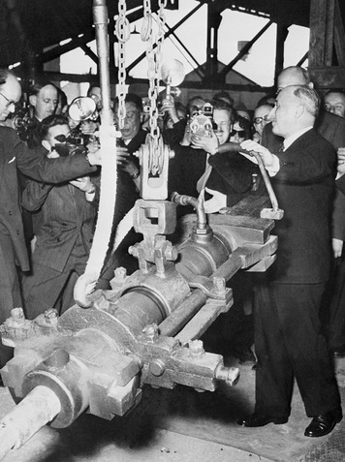
Globalization has resulted largely from a quest for free trade. After World War II, the United States and many European nations came to believe that free and open trade would benefit world economies and help prevent future conflicts among nations. The United States, especially, promoted free trade as a strategy for helping European economies recover from the war and as a way to keep nations out of the Soviet Union's sphere of influence. In 1951, six countries in Europe formed the European Coal and Steel Community to create a common market for those two products. A common market is a grouping of countries that promotes lower trade barriers among its members. Through the years, the European Coal and Steel Community expanded, and it added a political dimension to its goal of unifying the continent economically. Today, it is known as the European Union (EU).
European success at stimulating trade sparked other moves toward free trade. In 1994, the North American Free Trade Agreement (NAFTA) went into effect. Under NAFTA, the United States, Canada, and Mexico agreed to create their own common market. Their purpose was to get rid of trade barriers, especially tariffs, on goods and services traveling from one of the three countries to another. The United States has since negotiated free trade agreements with more than a dozen other countries.
Similar agreements have blossomed among countries all over the globe, often with the help of the World Trade Organization (WTO). Founded in 1995, the WTO is an international organization run by more than 150 member-nations. Its main goal is to reduce trade barriers throughout the world. It does so by offering a forum for countries to negotiate trade agreements and providing a set of rules to guide international trade. If a trade dispute arises, the WTO will help settle it.
Trade agreements tie countries together in a dependent relationship. A key requirement for such an agreement is that all participants must be able to profit from that relationship. They do so, in part, by making the most of their comparative advantage.

Comparative Advantage
A strong driver of free trade is an economic theory known as comparative advantage. The theory states that a country that can produce a good more efficiently than others has an advantage compared with its competitors. A country might derive an advantage from its geographic location, fertile farmland, mineral wealth, or highly educated workforce.
Free trade agreements reflect the real-life application of this theory. They allow countries to sell their trading partners the goods and services that they can produce more cheaply, and to buy from their partners goods and services that they need but cannot produce as cheaply.
From the 1800s well into the 1900s, industrialized countries grew wealthy from selling manufactured products. They could produce finished goods more cheaply and efficiently than less developed countries. But they relied on those countries for raw materials. Britain, for example, had a comparative advantage over Egypt in the production of textiles. Egypt, though, could produce cotton more efficiently than Britain. When those two countries engaged in trade, each made the most of its comparative advantage.
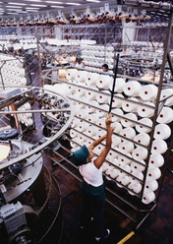
A country's comparative advantage can shift over time. Through most of the 1900s, Brazil, India, and China, like most of the world's less developed countries, were poor. They contributed raw materials to the world economy, but little else. Today, each of those countries has become much more competitive in global trade. Along with Russia, they are known as the BRIC economies (from the first letter of each country's name). They have been singled out for their potential to become economic powerhouses in the coming years.
Many developing countries have found that they have a comparative advantage in human resources, or labor. Wages paid there are often much lower than in developed countries. For this reason, they have attracted labor-intensive service and factory work once performed in the West and Japan. Today, for example, many poor but well-educated, English-speaking people in India work at call centers. By telephone, they handle sales and customer support for numerous American and British companies. In China, factory workers produce goods found in stores throughout the world.
The evolution of the corporation played a role in the globalization of labor. The classic multinational corporation was based in one country—mainly in the United States, Western Europe, or Japan. It did business in other countries through subsidiaries, or companies that it controlled. Government policies in a base country often helped corporations but also restricted their business practices. These policies generally encouraged corporations to keep jobs in the home country.
The 1990s and early 2000s saw a rise in mergers between companies based in different countries. The resulting global corporations essentially decoupled themselves from any one nation's resources—and their often restrictive government policies. Global corporations made business decisions based on their own priorities. One consequence was the outsourcing, or sending abroad, of jobs from developed to less developed countries. There the low cost of labor reduced the cost of production.
Today, corporations outsource not only unskilled but also skilled jobs. A computer sold in the United States, for example, may be designed by engineers in India and assembled by technicians in Mexico.
Distribution of Wealth and Resources
In spite of the economic impact of job losses, the developed nations are still the wealthiest nations of the world, at least for now. With generally high wages and standards of living, their citizens consume most of the world's goods, by far. In the process they use up a large percentage of the world's oil, metals, and other natural resources.
Many people in developing countries would like to enjoy the same standards of living as developed countries. This helps explain migration patterns. Each year, hundreds of thousands of workers head for North America, Western Europe, Japan, Australia, and elsewhere in search of a better life. Many of them send part of their earnings back to their families in their home country. That flow of cash, known as remittances, provides important economic support to households and to governments in many of those countries. In 2009, remittances worldwide topped $400 billion.
Impact of Globalization
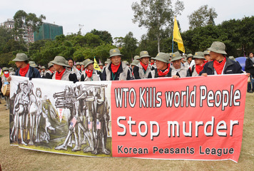
One criticism of globalization is that it has not closed the gap in standards of living between developed and developing countries. Another is that it forces developing countries to link their economies with the rest of the world even if they do not have the resources to compete successfully. As a result, critics say, those countries focus on the global marketplace and end up ignoring the needs of people locally. They also give up some of their sovereignty to powerful multinational corporations, which make economic decisions that can have a huge impact on a country.
Others insist that globalization has actually helped close the economic gap between developing and developed countries. The outsourcing of jobs, they argue, gives a welcome boost to developing economies. Workers in China and India, for example, can now afford consumer goods such as televisions and cars. To narrow the unequal distribution of wealth and resources, supporters of globalization insist that developing countries should be encouraged to pursue free-trade policies. In 2000, the Secretary General of the United Nations agreed, saying:
The main losers in today's very unequal world are not those who are too much exposed to globalization. They are those who have been left out.
—Kofi Annan, speaking at a United Nations convention, February 2000
Globalization includes more than just the exchange of goods. New ideas and inventions have always spread from region to region, but with globalization, scientific knowledge, medical advances, and new technology all pass easily across modern borders. Part of the reason for this is the information revolution. As countries build advanced communications systems, they connect themselves more effectively with the world.
Another result of this connectedness is the globalization of culture through a process of cultural diffusion. Today, in a world of global commerce, nearly any product can be sold nearly anywhere. But the developed world dominates global commerce. It also dominates the mass media—television, radio, movies, and the Internet. Through these channels, goods as well as ideas and values can flow. They can alter local cultures, changing the foods people eat, the way people dress, and even the way they think. With globalization, some cultural shift is inevitable. But nobody is sure what the impact will be or how globalization will affect traditional cultures.

Conflict, Cooperation, and Security
The Cold War ended in 1991 with the breakup of the Soviet Union. Throughout the world, people looked forward to a time of peace and security. Globalization did encourage cooperation—economic and political—among nations, but the world continued to be plagued by violent conflict.
Ethnic Violence
Many countries have more than one ethnic group living within its borders. Each group may have its own language, religion, or customs. In some of these countries, the clash of different cultures has led to extreme levels of bloodshed. Northern Ireland, Cambodia, Bosnia, Rwanda, and Sudan all have a recent history of ethnic violence.
Northern Ireland is part of the United Kingdom. It split off from the rest of Ireland in the 1920s because it had a Protestant majority loyal to Great Britain while the rest of Ireland was majority Catholic. In the decades that followed, Northern Ireland's Protestant majority used its political power and control of institutions to oppress the Roman Catholic minority. The Catholics fought for their rights, often using terror tactics such as bombings. The Protestants fought back, and the violence escalated.
Thousands of British troops were sent to the region to try to restore order. Only in the late 1990s was a lasting peace achieved, through a series of negotiations and compromises.
Cambodia experienced ethnic violence on an even more destructive scale. In 1975, after years of civil war, Cambodia fell into the hands of the guerrilla fighters of the Khmer Rouge. The Khmer Rouge was a radical communist political group. From 1975 to 1979, it engaged in an extreme campaign to destroy its enemies. Those supposed enemies included the wealthy, the educated, and the members of nearly every ethnic minority in the country. First the Khmer Rouge emptied the cities, sending most of Cambodia's urban population into the countryside to work the fields as forced labor. Many died from exhaustion, starvation, or disease. Mass executions of “class enemies” and ethnic minorities followed. This genocide resulted in the deaths of more than 1.5 million Cambodians.
Bosnia also experienced the horrors of ethnic violence. Bosnia and Herzegovina (or, simply, Bosnia) became a province of Yugoslavia in 1946. Ethnic tensions among its Serb, Croat, and Muslim populations boiled over into civil war in 1992, when Bosnia declared its independence from Yugoslavia. Bosnian Serbs opposed separation from Yugoslavia. In the war that followed the Serbs pursued a policy of ethnic cleansing, a brutal—but ultimately failed—attempt to expel all Muslims from Bosnia by force. Their tactics included rape and mass murder.
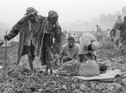
Those same tactics also appeared in the genocide that afflicted the African nation of Rwanda. Beginning in the early 1990s, rebels from the Tutsi ethnic group fought for power against the governing Hutu ethnic group, who far outnumbered them. A peace accord reached in 1993 was shattered that same year when the extremist nationalist Hutus began a killing spree. In a 100-day period, the extremist Hutus slaughtered some 800,000 people throughout the country. The victims were Tutsi men, women, and children and some moderate Hutus. Tutsi forces later defeated the Hutus and ended the genocide.
In Sudan, ethnic conflict pitted the governing Arab Muslims of the north against a small minority of African Christians and followers of native religions in the south. The southern Sudanese had long complained of mistreatment by the government. Starting in the mid-1980s, defiant southerners launched a guerrilla war aimed at liberating their region from the north. The warfare left some 2 million Sudanese dead. In 2005, a peace treaty opened the door to self-rule. In 2011, the southern region became the independent nation of South Sudan.

Lingering Sources of Tension and Conflict
The splitting of Sudan did not bring peace. Violent clashes between feuding ethnic groups continued elsewhere in Sudan, namely in the western region of Darfur where non-Arab tribes face vicious attacks from government-supported militias. To a lesser degree problems continue in South Sudan itself. Ethnic discord in this region of Africa is just one of several lingering sources of tension and conflict in the 21st-century world. Another is instability in the Middle East.
The Middle East today is home to about a dozen states with a majority Muslim population. Israel, a Jewish state in this otherwise Muslim region of the world, has long faced hostility from its neighbors.
Two ongoing sources of conflict have been rejection of Israel's right to exist and Israel's control of areas that the largely Muslim Palestinian Arabs want for their own state.
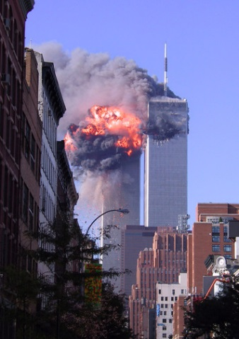
Another source of instability in the Middle East is the presence of radical Islamic terrorist organizations. The United States became a target of radical Muslim terrorists on September 11, 2001. The 9/11 attacks on the twin towers of the World Trade Center in New York City and on the Pentagon killed nearly 3,000 people and led to a global “war on terror.” The war began with a U.S.-led invasion of Afghanistan. That was where Osama bin Laden, the mastermind of the 9/11 attacks, had based his terrorist organization, known as al Qaeda.
U.S. troops intended to find Osama bin Laden and destroy al Qaeda. Ten years later, in neighboring Pakistan, an American assault force finally located and killed bin Laden. By that time, al Qaeda's strength had been steadily reduced. However, as American troops prepared to withdraw from Afghanistan, the country remained unstable, its future uncertain.
In 2003, the United States also invaded Iraq. The U.S. government had intelligence that led them to believe that Iraqi leader Saddam Hussein was stockpiling weapons of mass destruction (WMD). The goal of the invasion was to find and destroy those weapons, whether chemical, biological, or nuclear.
Over time, troops did uncover a few aged chemical weapons but no significant stores of WMD. Soon after invading Iraq, U.S. forces drove Saddam Hussein from power. However, the Iraq War turned out to be a long and costly struggle against remnants of Saddam Hussein's regime and various Muslim militias and extremist groups, including al Qaeda.
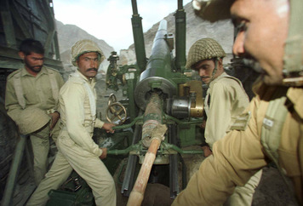
In early 2010, Iraqis elected a national government. The United States formally ended its military operation in Iraq in late 2011 after nearly nine years of war. Nearly 4,500 U.S. troops were killed in Iraq and more than 30,000 were wounded. Estimates of Iraqi civilian deaths were in the tens of thousands.
Some extremist groups in the Iraq War received military training and arms from Iran. In the early 2000s, this Islamic republic steadily gained power and influence in the Middle East. Many in the West feared that Iran was seeking to develop nuclear weapons. The Iranians, however, insisted that their nuclear program had only the peaceful goal of producing nuclear power.
Two countries to the east of Iran—Pakistan and India—do possess nuclear weapons. What makes this a worrisome situation is that these South Asian countries are fierce rivals. A major source of tension between them is the region of Kashmir. Kashmir lies east of Pakistan and north of India.
About 48 percent of Kashmir is under Indian occupation and 35 percent is occupied by Pakistan, with the remaining territory under control of China. Like Pakistan but unlike India, Kashmir's population is mainly Muslim. Pakistani troops have, on occasion, moved into Indian Kashmir in support of those who want to separate from India. Their actions led to wars in 1965 and 1999. Violence in the region has claimed more than 40,000 lives, and Kashmir continues to be a potential flashpoint in relations between India and Pakistan.
The Struggle for Democracy
In the 1970s and 1980s, authoritarian rule seemed to be yielding steadily to democracy. From South Korea to South Africa, from Czechoslovakia to Chile, dictatorships gave way to democracies. By and large, these regime changes did not come about through violent revolution. The causes were complex. They included rising levels of education and prosperity, increasing demands for human rights, and pressure for political change. Unpopular policies instituted to deal with a failing economy helped undermine many authoritarian governments as well.
By the late 1980s, even the Soviet Union found itself struggling to maintain communist rule. Its unproductive system of collective farming had led to food shortages. Its huge military budget had sapped the economy of resources. Economic reforms (perestroika) and political reforms (glasnost) ultimately led to a fairly peaceful transition to capitalism and democracy.
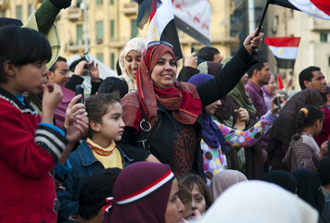
In the early years of the 21st century, progress toward democratization continued. It centered on North Africa and the Middle East, where strong rulers kept their people oppressed. Activists in these countries had long sought democratic reforms, but authoritarian government persisted. Then, in 2011, a remarkable series of popular revolts swept this largely Arab Muslim region. Together, they became known as the Arab Spring.
The first uprising occurred in the North African country of Tunisia. Starting in December 2010, Tunisians, many of them young and unemployed, took to the streets to protest the lack of jobs, high food prices, poverty, and government corruption. In mid-January 2011, the growing demonstrations caused Tunisia's president to flee the country.
Tunisia's outburst of democratic action triggered other revolts. By the end of January 2011, pro-democracy demonstrations broke out in several Egyptian cities. In April 2011, massive, largely peaceful protests in the capital city of Cairo led to a dismantling of the government and the arrest of Egypt's president, Hosni Mubarak. In Egypt, as in Tunisia, social media played a key role. Activists used Facebook and Twitter posts to help organize and spread information about the uprising.
Demonstrations also took place in Algeria, Yemen, Lebanon, Iran, Bahrain, Syria, and elsewhere. The level of violence varied. In Libya, anti-government actions took the form of an armed rebellion. With the help of NATO air strikes, the rebel army managed to gain control of the country in August and oust the Libyan dictator, Muammar al-Gaddafi. He was killed shortly after his capture by the opposition.
Antigovernment unrest in Syria began in early 2011. Syria's dictatorship government, led by Bashar al-Assad, responded with military force. The government sent out troops and tanks in a sustained effort to suppress the rebellion. The United States, France, Germany, and the United Kingdom called on Assad to step down, but the crackdown continued into 2012. By early 2012, more than 7,000 Syrians had died.
The future of democratizing countries is uncertain. Throwing off authoritarian rule is not easy. Neither is replacing it with a democratic government. Countries in transition to democracy, however, do not need to go it alone. Just as NATO supported Libyan freedom fighters, other global organizations stand ready to help in the transition to democratic rule. The United Nations made clear its intention to promote justice, human rights, and political security in the region. The World Bank and the International Monetary Fund (IMF) promised aid as a way of encouraging economic security and stability.

